

Electromechanical
Pakita Siren LC type

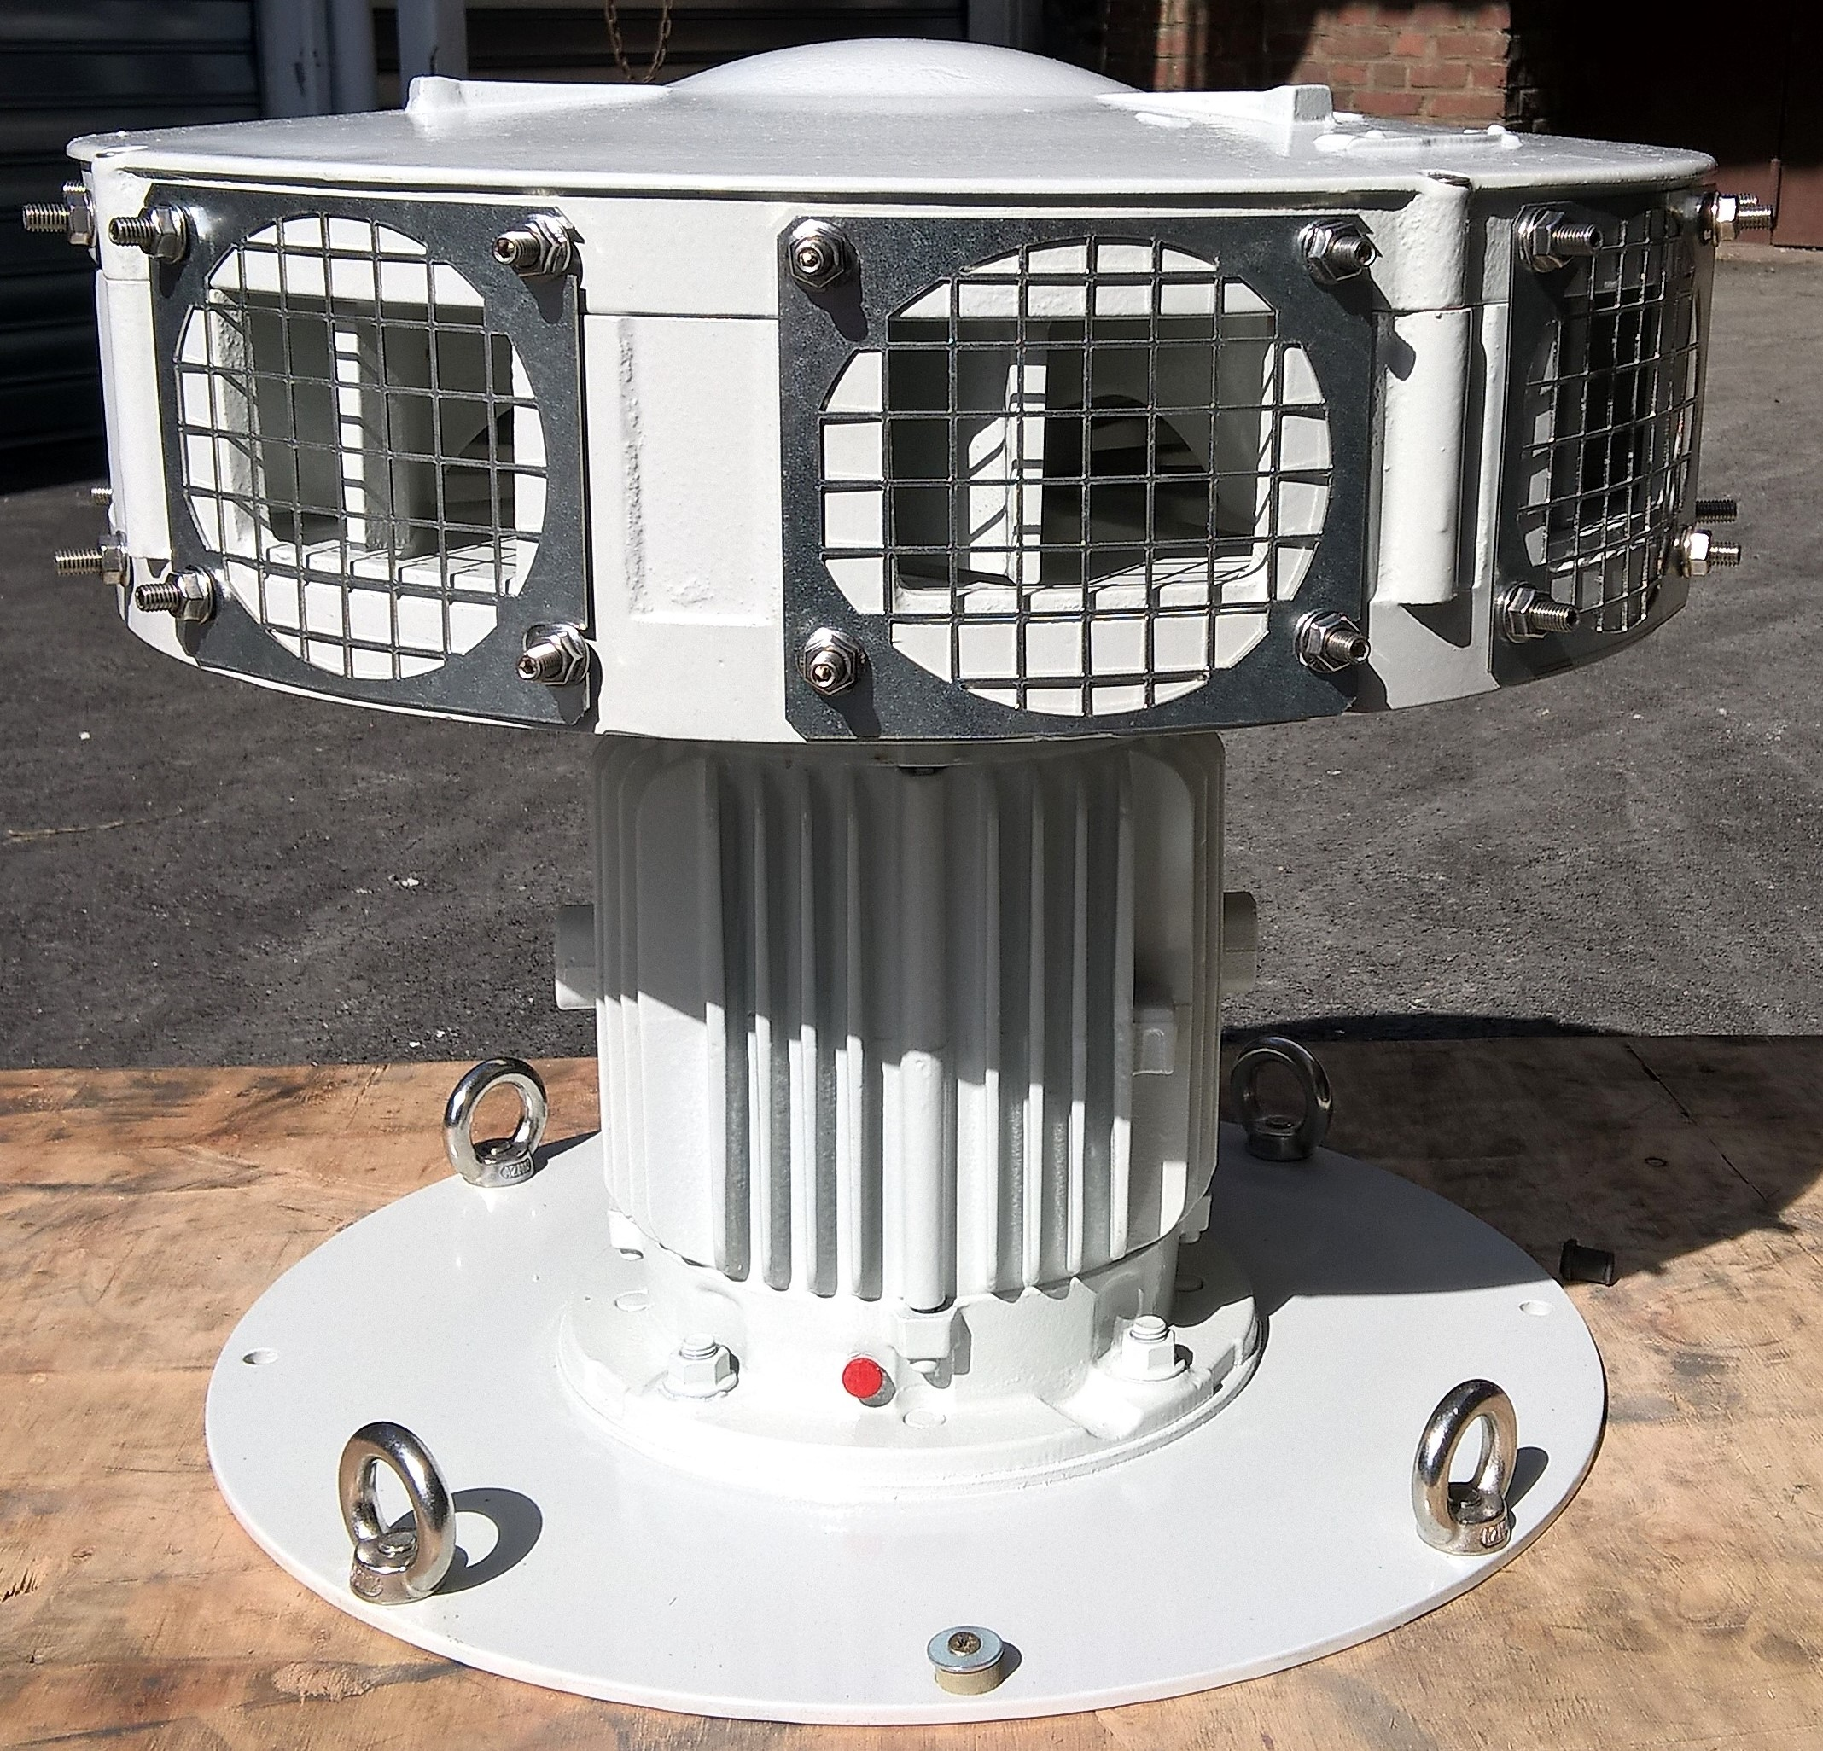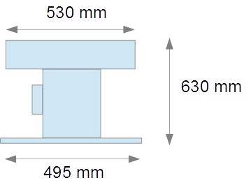

- Weight : 72 kg

- Head in Aluminum AS10G

- Asynchronous motor : Three-phase 230V/400V – 2750 rpm

- Sound power : 120 dBA at 10 meters

- Sound : 380Hz - Sharp F - 3th octave

- Lifting ring and attachment hole with ∅ 465 mm (distance between two opposing holes across the axe)

- Options :

  - Control Box or Control Cabinet
  - A set of 8 galvanized loudspeaker Horns
  - A set of 8 stainless-steel loudspeaker Horns
  - Proximity shut off switch
  - Elevating base ∅ 495X330 mm

