

Electromechanical
PAKITA Siren PP type

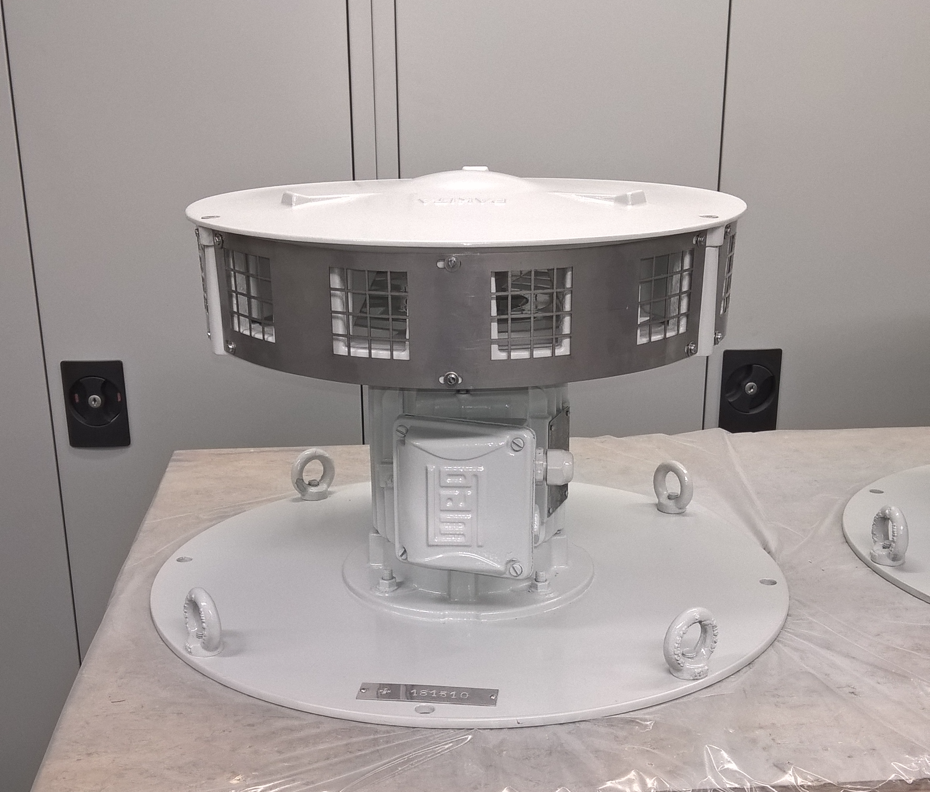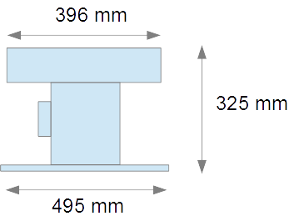

- Weight : 40 kg

- Head in Aluminum AS10G

- Three-phase asynchronous motor : 1,1 kW - 230V/400V – 2750 rpm

- Sound Power : 105 dBA at 10 meters

- Sound : 570 Hz - Flat D – 4th octave

- Lifting ring and attachment hole (∅ 10mm) with ∅ 465 mm (distance between two opposing holes across the axe)

- Options :

  - Control Box or Control Cabinet
  - Single-phase motor 230V – 50 Hz
  - Proximity shut off switch
  - Elevating base ∅ 495X330 mm

